IST 363

Lab 10

react 1
- paste screenshot here
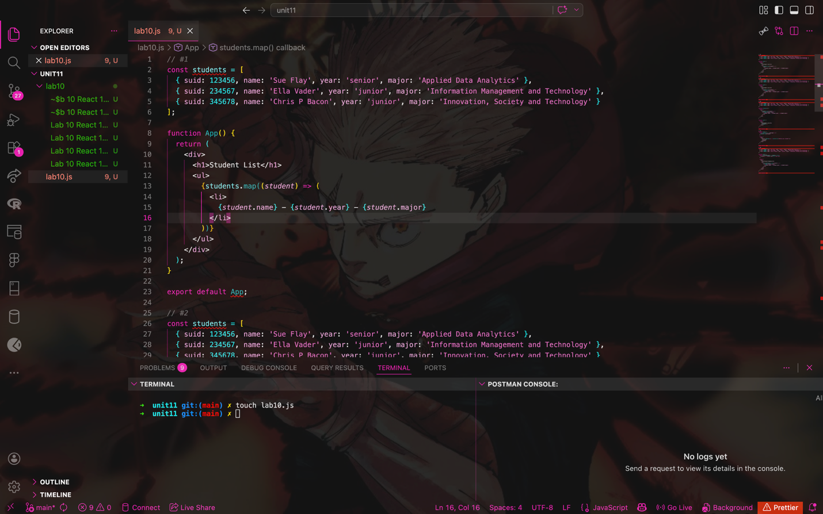

- paste screenshot here

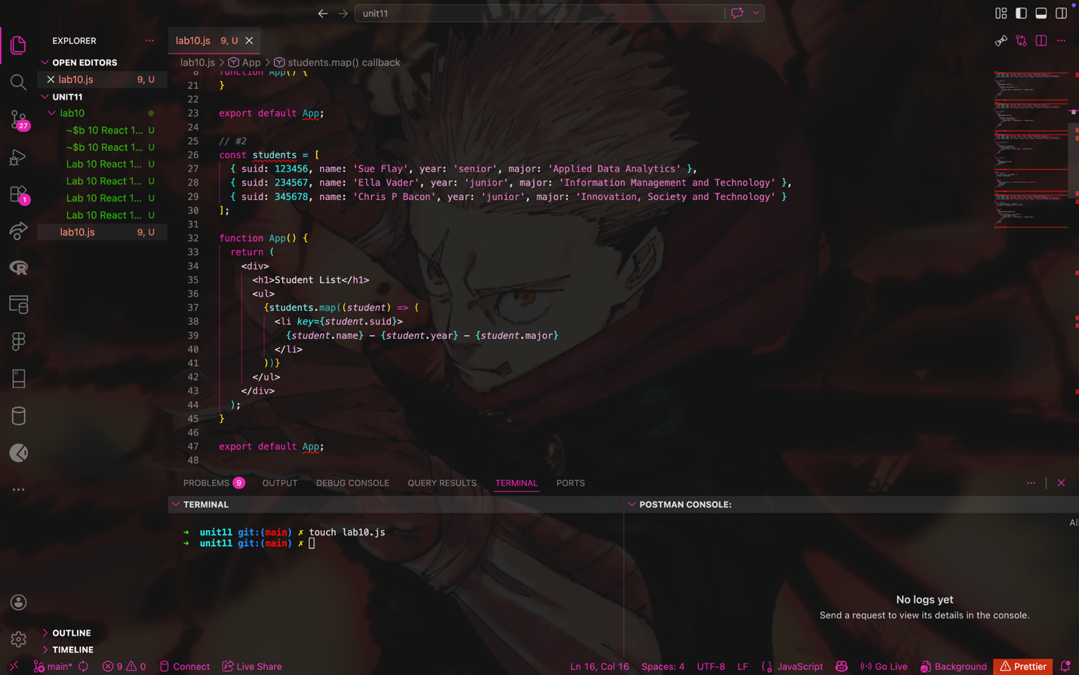
- paste screenshot here

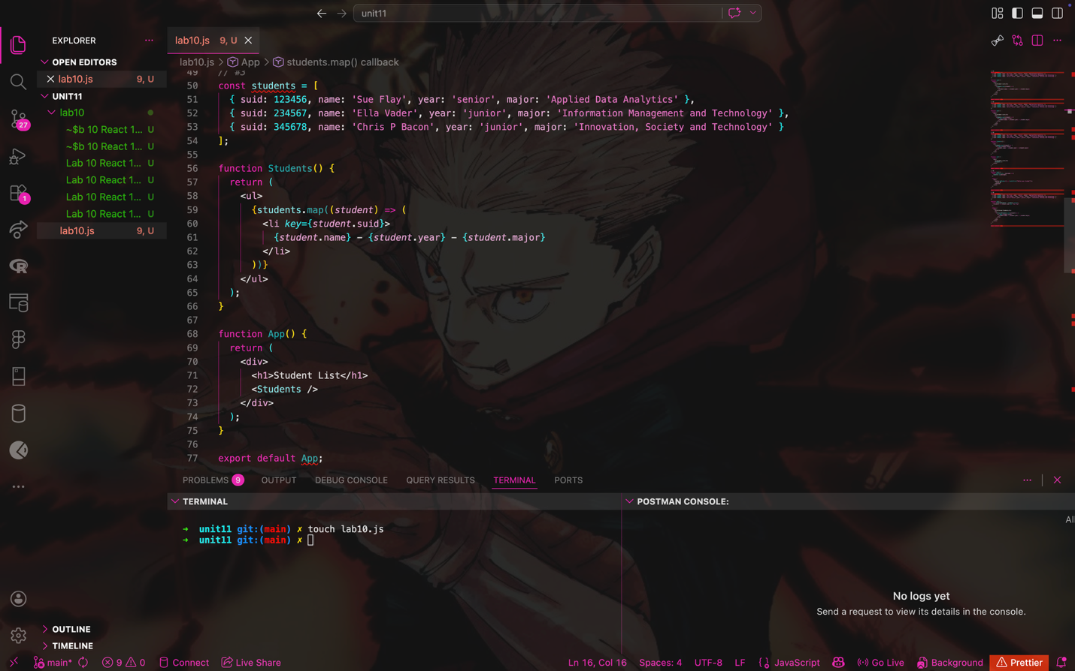
- paste screenshot here
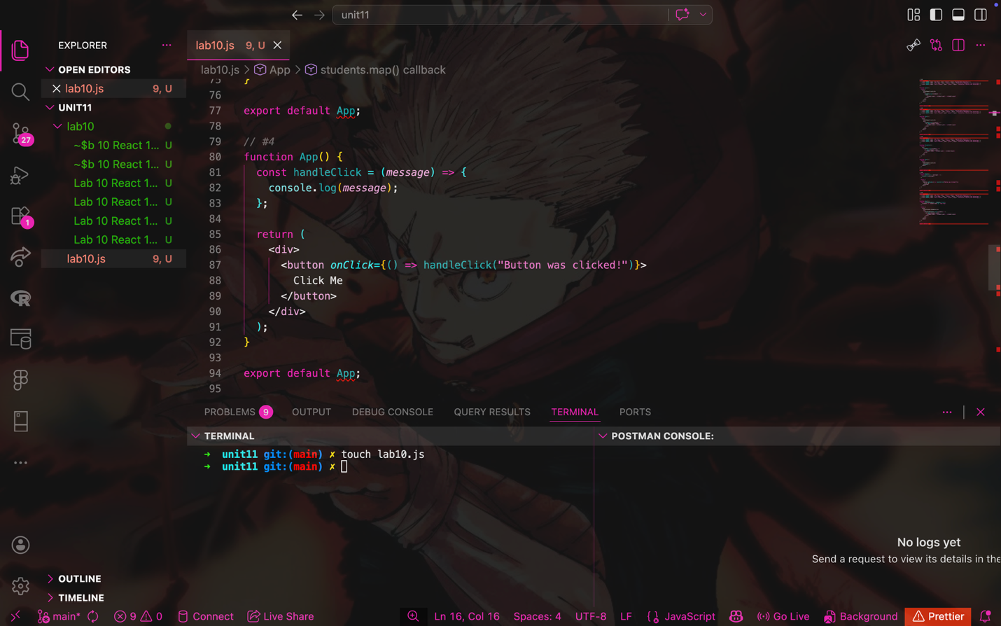

- paste screenshot here

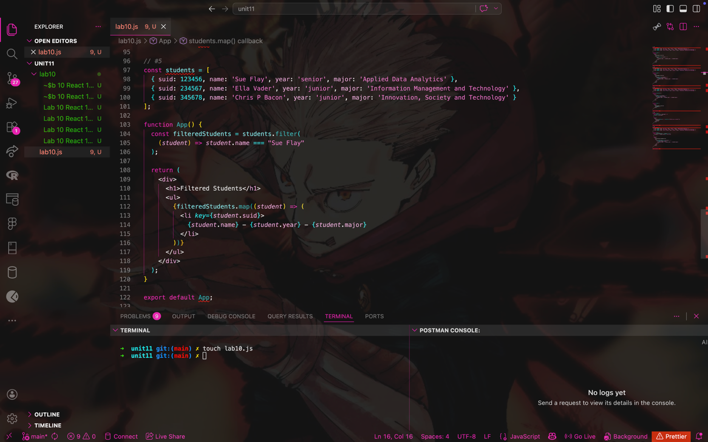

6. write brief answers to the questions below
a.
React components are reusable pieces of UI that help organize code and make apps easier to manage.
b.
They must start with uppercase so React knows it is a component and not a regular HTML tag.
c.
JSX is a syntax that looks like HTML but lets you write JavaScript inside it.
d.
We use className because class is a reserved word in JavaScript.
e.
You use curly braces {} to insert JavaScript inside JSX.
f.
It makes code cleaner, easier to read, and easier to reuse.
g.
When a component gets too big or does too many things.
h.
Yes, you can reuse components by calling them like multiple times.
i.
React handles inputs using state and events like onChange to track user input.

